* You can create the users from IAM section type IAM in search bar and click on the users,  
  in the access management we have a user option click on that. On right-hand side you have an option like create user click on that option.  
    
  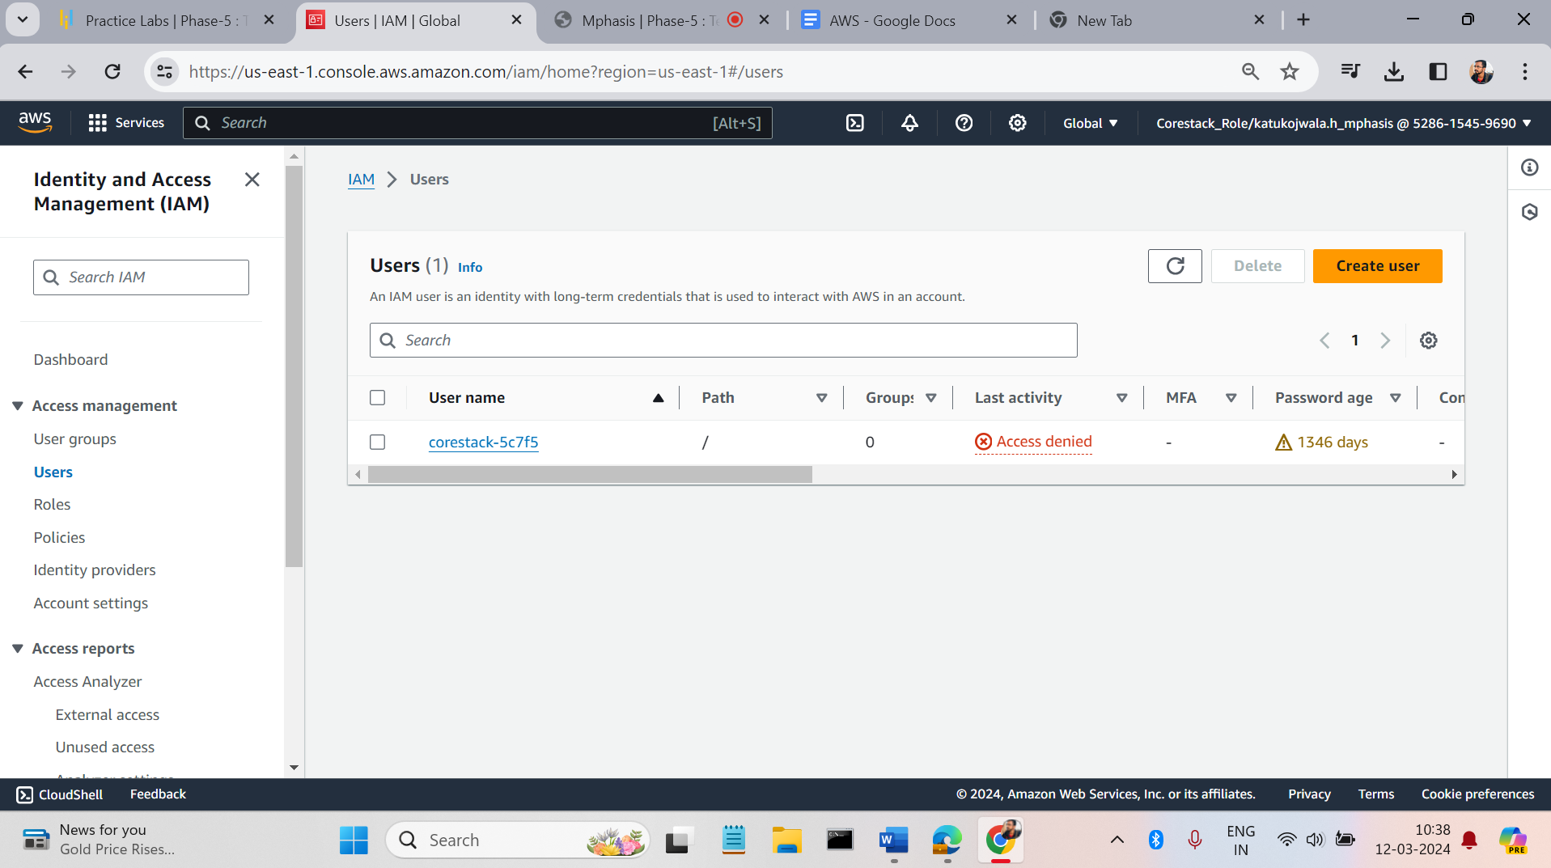
* Enter user name and click on next  
    
  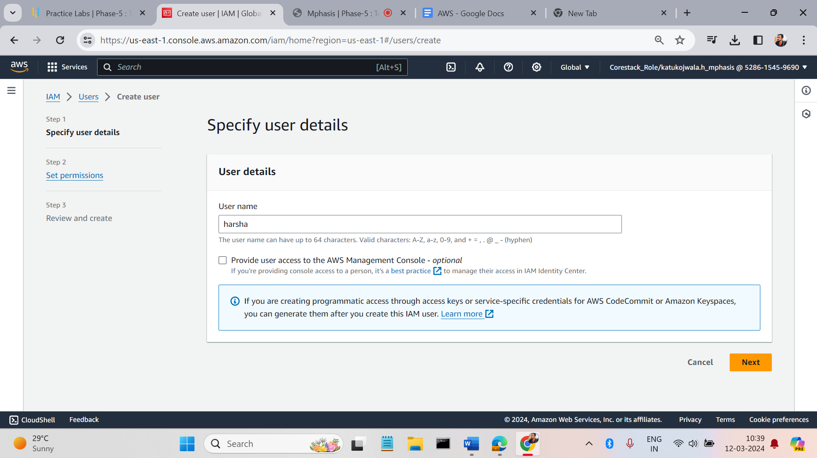
* Use all default and click on next  
    
  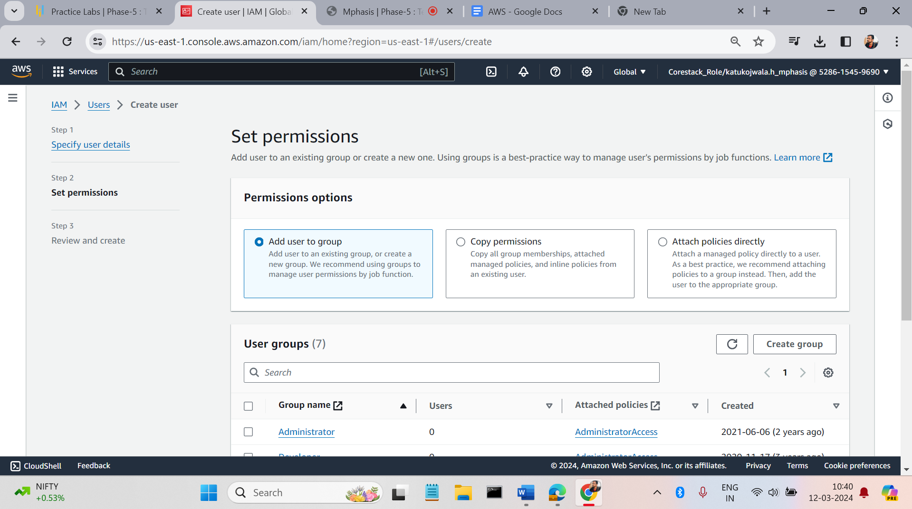
* Click on create user a user will de created.  
    
  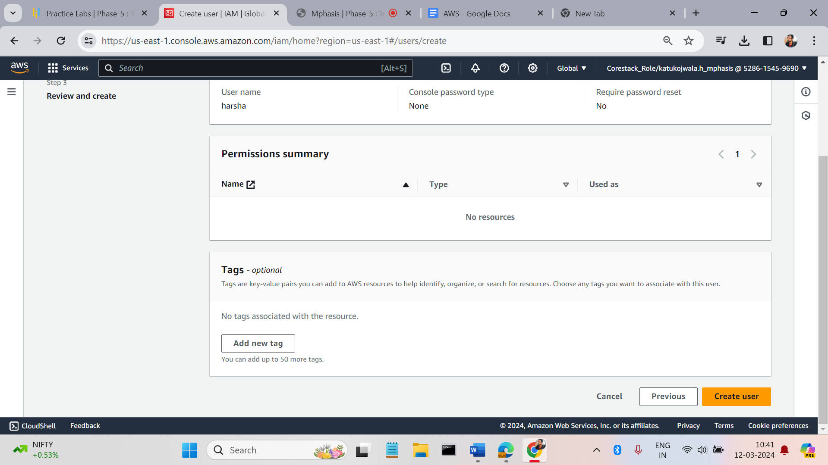
* Click on the user and go to security credentials and click on the enable console access  
    
  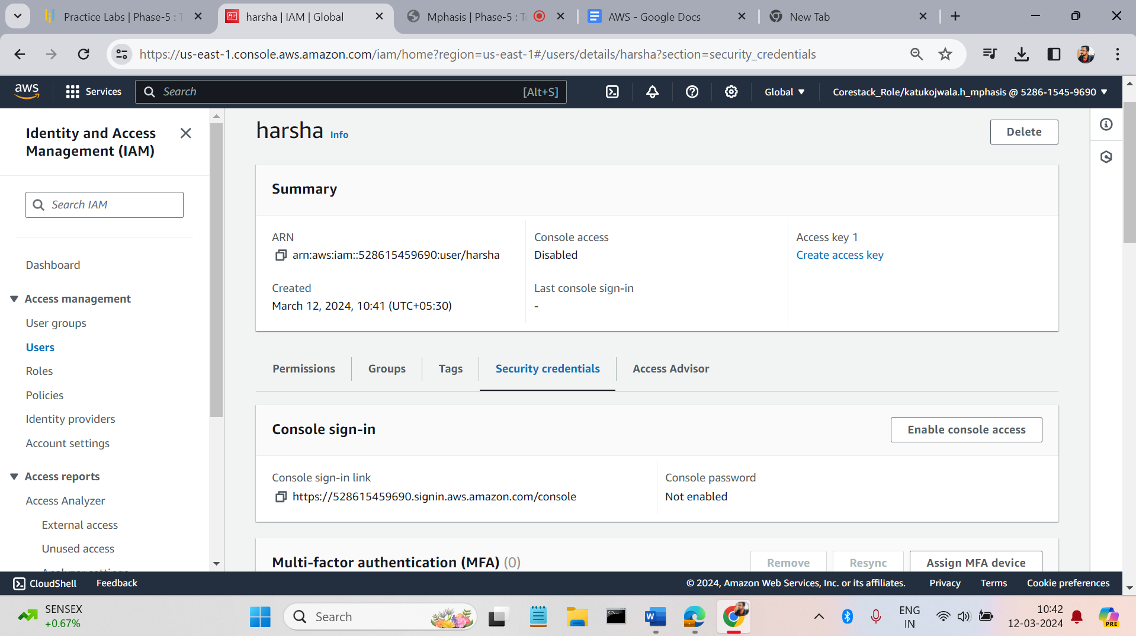
* Click on enable.  
    
  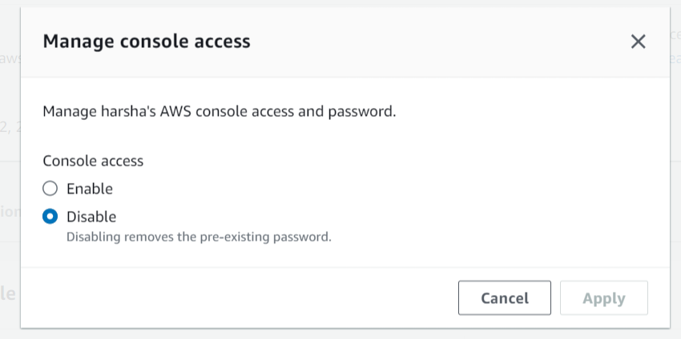
* Click on custom password and give the password. Click apply.  
    
  